**Name: Shivam Tiwari**

**Roll No: 5117060**

**Aim:** User Management in Owncloud.

**Steps:**

The Default View of Users on the OwnCloud Landing Page

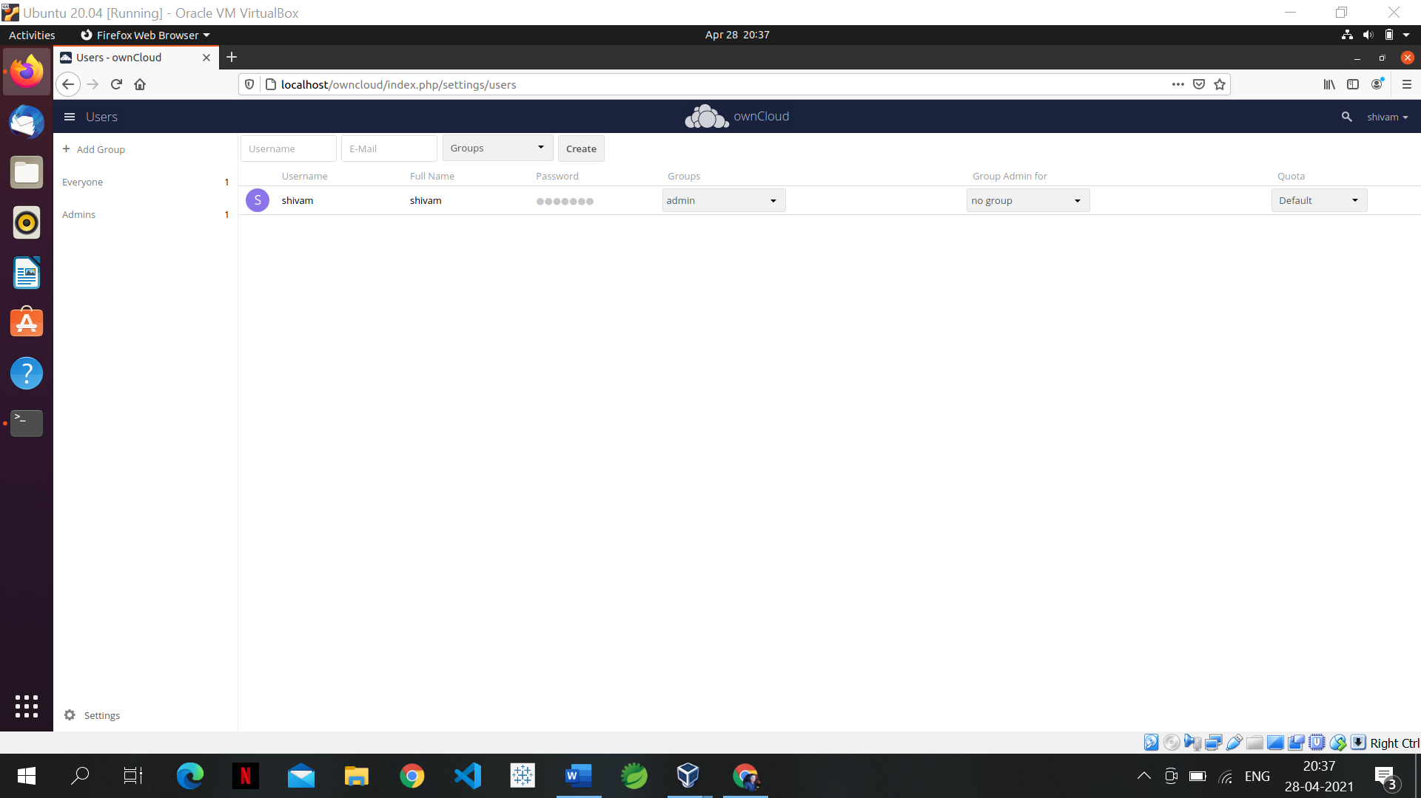

**Some Information about OwnCloud User Account Structure**

User accounts have the following properties:

* **Login Name (Username)**

The unique ID of an ownCloud user, and it cannot be changed.

* **Full Name**

The user’s display name that appears on file shares, the ownCloud Web interface, and emails. Admins and users may change the Full Name anytime. If the Full Name is not set it defaults to the login name.

* **Password**

The admin sets the new user’s first password. Both the user and the admin can change the user’s password at anytime.

* **E-Mail**

The admin sets the new user’s E-Mail. The user then get’s an E-Mail to set his Password. Both the user and the admin can change the user’s E-Mail at anytime.

* **Groups**

You may create groups, and assign group memberships to users. By default new users are not assigned to any groups.

* **Group Admin**

Group admins are granted administrative privileges on specific groups, and can add and remove users from their groups.

* **Quota**

The maximum disk space assigned to each user. Any user that exceeds the quota cannot upload or sync data. You have the option to include external storage in user quotas.

**Creating a new user**

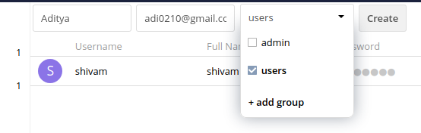

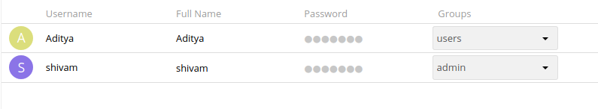

**Resetting Password**

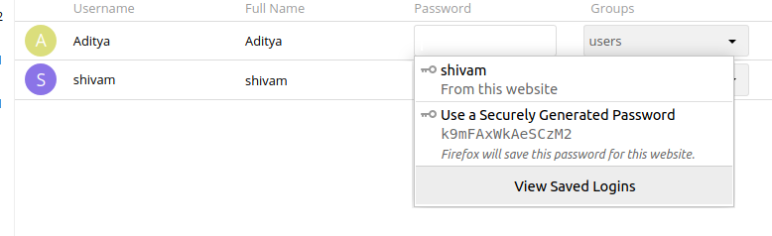

**Renaming User**

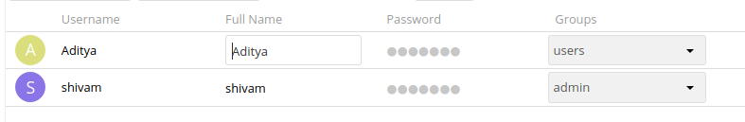

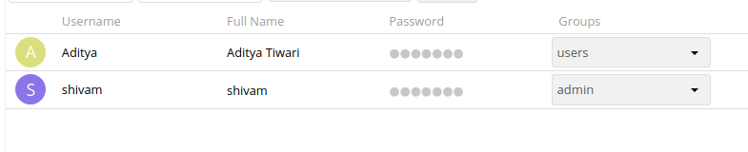

**Deleting User**

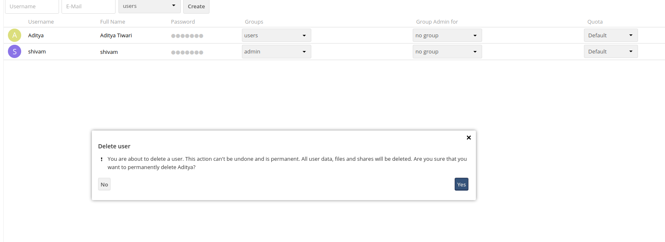

**Granting Administrator Privileges**

Own cloud has two types of administrator

* **ownCloud Administrators** have full rights on your ownCloud server, and can access and modify all settings. To assign the ownCloud Administrators role to a user, simply add them to the admin group.

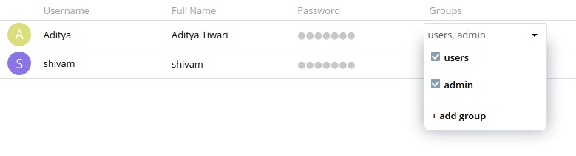

* **Group Administrators.** Group administrators have the rights to create, edit and delete users in their assigned groups. Use the dropdown menus in the Group Admin column to assign group admin privileges.

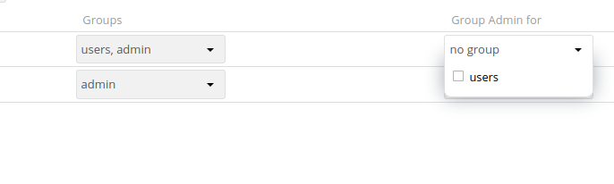

**Managing groups**

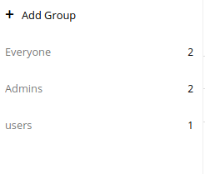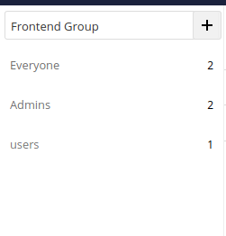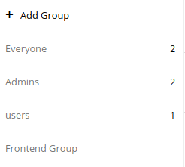

**Enabling Custom Groups**

Owncloud Market Place

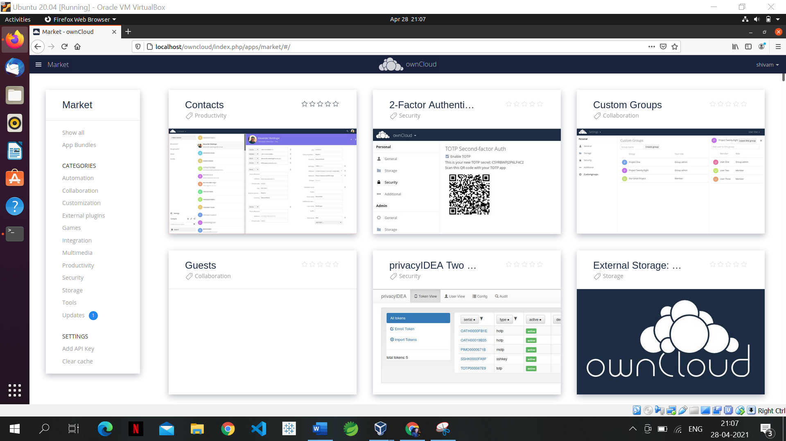

Select ‘Collaboration’ as a category

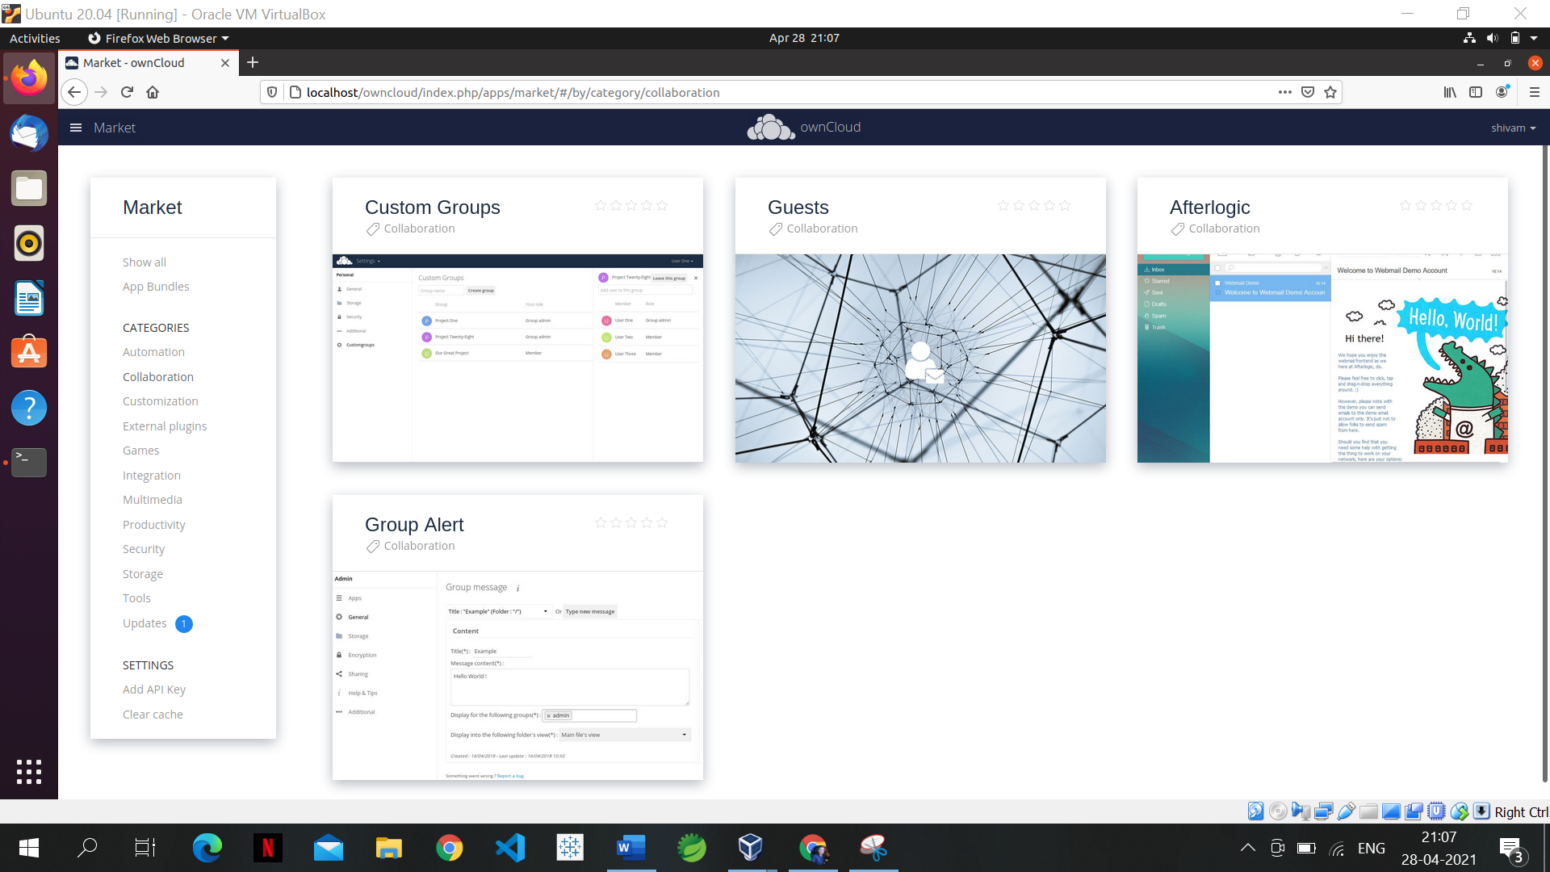

Choose Custom Groups -> Install

